WORKBOOK

  - Looking Ahead: Identifying and Articulating Teaching Success | CTSI Demystifying the Dossier Workshop Series | October 26, 2021

CONTENTS

- Activity #1: Initial Brainstorm Re: Teaching Success
- Activity #2: Mapping Your Educational Leadership Using the 5-Pillar Model
- 7 Steps to Identify & Articulate Teaching Success
- APPENDIX A – Documenting Your Teaching Template
- APPENDIX B – Worksheet to Process Teaching Data: Critical Reflection on Your Work as a Teacher
- APPENDIX C – Examples of Educational Leadership
- APPENDIX D – Strategic Professional Development
- APPENDIX E – Educational Leadership Mapping Tool

ACTIVTY #1:

When do you feel successful as a teacher?
- text

What contributes to this success?
- text

ACTIVITY #2: Mapping Your Educational Leadership

Considerations of Educational Leadership:

Educational leadership is a difficult concept to define and can have many interpretations depending on context. A review of relevant literature offers several operational definitions of educational leadership. In their poster, A Developmental Framework for Teaching Expertise in Postsecondary Education, Natasha Kenny, et al., (2017) describe educational leadership as a key facet of teaching expertise:

Educational leaders influence change and implement initiatives to strengthen teaching and learning practices, communities, and cultures (Keppell, O’Wyer, Lyon & Childs, 2020; Mårtensson & Roxå, 2016; STLHE, n.d.) They share their expertise to inspire and help others strengthen their teaching practices; implement strategic programs, initiatives and policies to improve teaching and student learning; advocate for positive change; and, lead institutions, faculties and committees to continuously improve postsecondary education
(Creanor, 2014, Mårtensson & Roxå, 2016, STLHE, n.d., Taylor, 2005; UBC, n.d.; University of Calgary, n.d.). (p.4)

This activity asks you to consider the leadership characteristics identified in the 5-Pillar Model. Developed at the University of Calgary, this framework is based on emergent themes from interviews with individuals identified as educational leaders in higher education through their participation in an academic development program focused on educational leadership. The characteristics laid out below are not expected to be personified all the time and in every context; rather, they can include the qualities outlined in the chart.

- In the following table, try to identify one example from your own practice in each of the five areas (the 5 “pillars”) below.
- Try to identify one or more goals in the areas below – things you may not be doing now but are actions you aspire to.

5-Pillar Model of Educational Leadership

Fields, J., Kenny, N. & Mueller, R. (2019). Conceptualizing educational leadership in an academic development program. International Journal for Academic Development. 1-14. 10.1080/1360144X.2019.1570211.

Pillar | ONE example of something you are currently doing … | ONE area you would like to demonstrate (more) leadership – what could you do to work towards this?
Affective Qualities
- Demonstrating humility
- Showing respect and empathy
- Establishing trust
- Facilitating relationship-building
Action Orientation
- Effective change
- Taking risks
- Facilitating long-term transformation
- Creating & implementing new teaching & learning projects
Mentoring & Empowering
- Helping colleagues strengthen their teaching & learning practices
- Mentoring & coaching colleagues
- Sharing resources
- Building capacity for growth
- Sharing insights & advice
- Bringing colleagues together
Teaching Excellence
- Facilitating student learning
- Enabling and empowering students
- Inspiring and building learners’ confidence
- Eliminating barriers to learning
- Being exemplary teachers
- Effectively communicating and collaborating with students
- Improving student learning experiences

Research & Scholarship
- Engaging in research
- Applying & disseminating scholarship in teaching and learning

7 Steps to Identify & Articulate Teaching Success

- UNDERSTAND YOUR CONTEXT
- How much do you know about the context in which you’re teaching?
- What are the degree learning outcomes for your program/department?
- How do your courses fit within the overall program structure?
- What are the key “burning issues” in your disciplinary area right now? How are these affecting how the discipline is being taught?
- What are the key issues facing students…
  - In your discipline?
  - In your department?

- COMPILE COURSE INFORMATION
- For each iteration of each course…what changed?
- What was your key contribution to each course offering?
- If you developed or will be developing courses from scratch...why?
  - What need do these new courses fill?
- What information/data/resources do you use to build new courses?
- What information/data/resources do you use to refine existing courses?

- DOCUMENT YOUR TEACHING PRACTICE
- Keep a teaching journal that captures your personal observations on...
  - In-class Activities / Tutorial / Lab Designs
  - Lecture Outlines
  - Assessment Designs
  - Debrief of Teaching Sessions with Co-instructors or TAs
- Use a template (Appendix A)
- Use milestones, e.g. first time a new assignment is implemented, whenever the first major evaluation in a course takes place, review of mid-course feedback, students’ reactions to a new or revised in-class activity, etc.
- E.g., have a running file that you contribute to at regular points…
  - After final week of classes in each term
  - When you debrief course experiences with TAs and colleagues
  - At the end of each full academic cycle – big picture overview
  - Every time a student gets in to graduate school, goes on to a career in your field or of their choice, defends, etc.
  - Every time you have a breakthrough with a particular student/group of students or a particular concept

- COLLECT SAMPLES OF STUDENT WORK (OPTIONAL!)
- Can demonstrate effectiveness of instructor feedback
- Can further illustrate/illuminate teaching methods
- Keeping samples of student work
  - Ask permission
  - Ensure anonymity
  - What to keep – work that shows student progress/improvement or includes examples of your feedback

- GATHER INFORMATION FROM OTHERS
- Solicited information/feedback from colleagues (e.g. co-instructors in a team-taught course)
- Unsolicited communications from colleagues or students – when reporting in an official document, e.g. a teaching dossier, always check with Chair about what to include!
- Written feedback from a peer observation of your teaching
- Evidence that course materials you have designed have been taken up by others in their courses
- Evidence that your scholarship and/or teaching resources have been taken up in courses at other institutions

- COLLECT, COMMUNICATE AND USE FEEDBACK
- Seek feedback: Mid-course feedback, summative course evaluation data, peer observations, observation or consultation with a teaching support centre, etc.
- Sort, evaluate and communicate about feedback
- Make a plan: Instructional activities, teaching goals, assessments & assignments, instructor items for course evaluations, learning outcomes
- Do it! Repeat!

- TRIANGULATE AND PROCESS YOUR TEACHING DATA
After reviewing collected materials, try reading across the materials to consider:
- key themes that emerge
  - use a key-word approach to analyzing the language that is used in your materials
  - colour code key ideas
- key questions to answer
  - how do I know what I do works?
  - what kind of approach to teaching do the materials capture?
  - do I demonstrate leadership?
  - do I implement changes:
    - based on feedback from others?
    - based on shifts in the discipline?
    - based on new understandings of student needs? based on a review of current scholarship?
  - can I provide evidence of impact on students?
- isolate challenges for special consideration

APPENDIX A – Documenting Your Teaching Template

What is working?

What needs to change?

New ideas

Key questions from students

Key blocks to students’ learning

APPENDIX B – Worksheet for processing teaching data: Critical reflection on your work as a teacher

After reviewing collected materials, try reading across the materials to consider:

KEY THEMES THAT EMERGE  - use a key-word approach to analyzing the language that is used in your materials  - colour code key ideas | KEY QUESTIONS TO ANSWER  - how do I know what I do works?  - what kind of approach to teaching do the materials capture?  - do I demonstrate leadership?  - do I implement changes:  - based on feedback from others?  - based on shifts in the discipline?  - based on new understandings of student needs?  - based on a review of current scholarship?  - can I provide evidence of impact on students?
ISOLATE CHALLENGES FOR SPECIAL CONSIDERATION

APPENDIX C – Examples of Educational Leadership

- Have you helped mentor junior colleagues or graduate students (including TAs)?
- Have you helped colleagues, or the department, navigate changes to courses and curricula?
- Have you contributed to teaching and learning committees, within or outside the university?
- Have you contributed to the improvement of instruction in the department by sharing your own resources/techniques, or researching other resources and techniques and bringing these into the department?
- Have you investigated your teaching in any way?
- Have you disseminated information about your teaching successes and/or challenges through inquiry?
- Have you engaged in community activities/outreach?

APPENDIX D – Strategic Professional Development

Some examples of professional development that may fuel your thinking and/or practice and lead to educational leadership activities, are as follows:
- Workshops, courses or trainings related to teaching
- Conferences, symposia related to teaching
- Reading and review of teaching and learning scholarship
- Inquiry on teaching and learning
- Mentoring (as both mentor and mentee)
- Observing peers’ teaching (within and outside your field)
- Communities of Practice, reading groups, brown bag lunch series
- Support or services offered through teaching and learning centres
When/if reporting on these activities, for example in your teaching dossier, it is recommended to also highlight what you have learned through these activities, and how you have applied this learning to enhancing your own teaching or the teaching of others.

APPENDIX E - Educational Leadership Mapping Tool

The University of British Columbia has created an Educational Leadership Mapping (ELM) tool, which provides faculty members with a framework by which to organize and plan educational leadership activities. While the map (pictured below, with definitions following) aligns specifically with UBC teaching and learning priorities and requirements, it nonetheless provides examples that can be useful to organize your thinking.

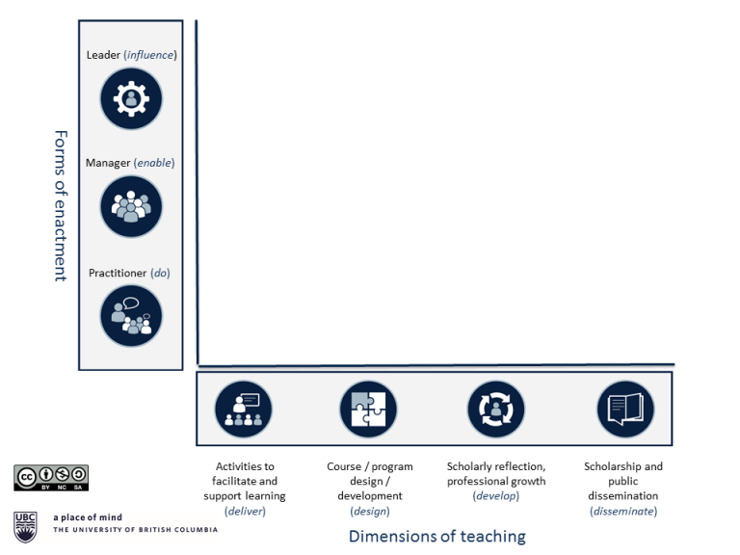
https://ctlt.ubc.ca/programs/all-our-programs/teaching-and-educational-leadership/an-educational-leadership-mapping-elm-tool-for-teaching-and-educational-leadership/

Dimensions of teaching – activities of an educator
1. Delivery. This refers to the broad range of activities that support and facilitate learning, including the time spent interacting with students in class, out of class, in office hours, seminars etc. The key feature is that activities that fall within this dimension are directly observable by students.
2. Design. The design and development of opportunities for learning: Development and design of modules, courses, program and curricula. Generally not observable directly by students, but vital to the coherence of the educational offerings they receive.
3. Development. The personal and professional growth from engaging in a process of reflective and scholarly teaching. This is part of an on-going process by which we understand, reflect on, and modify our approaches or attitudes to teaching based on interactions with colleagues, collaboration with other experts, from experience and reflection and from staying current with our disciplinary practices.
4. Dissemination. The combined elements of scholarship and dissemination, making public the processes and outcomes of our reflective enquiry, experimentation and evaluation of teaching and learning innovations, activities and approaches.
Forms of enactment – the ways in which these activities are expressed or realized, their locus
The dimensions of teaching activity just described are realized in different ways and by both individuals and groups and have different points of impact. This axis separates these forms of enactment into three areas:
1. Practice. The practice of teaching and learning: what is done as part of the work of the individual.
2. Management. The enabling of teaching and learning: the creation organizational conditions and execution of processes to support learning and teaching. There is a strong overlap with management and service contributions in the area of teaching (“doing things right”) and contributions to the work of a group, team or combined effort.
3. Leadership. The leadership of teaching and learning: embedding notions of enhancement, innovation and change, with impact that extends beyond one’s own classroom. The activities undertaken to lead, influence and support others to innovate, enhance or change their practice or approach in any of these areas of teaching.
- Excerpted from An Educational Leadership Mapping (ELM) tool for teaching and educational leadership, (n.d.), Vancouver: University of British Columbia.

